Given an n x n binary grid, in one step you can choose two **adjacent rows** of the grid and swap them.

A grid is said to be **valid** if all the cells above the main diagonal are **zeros**.

Return *the minimum number of steps* needed to make the grid valid, or **-1** if the grid cannot be valid.

The main diagonal of a grid is the diagonal that starts at cell (1, 1) and ends at cell (n, n).

**Example 1:**

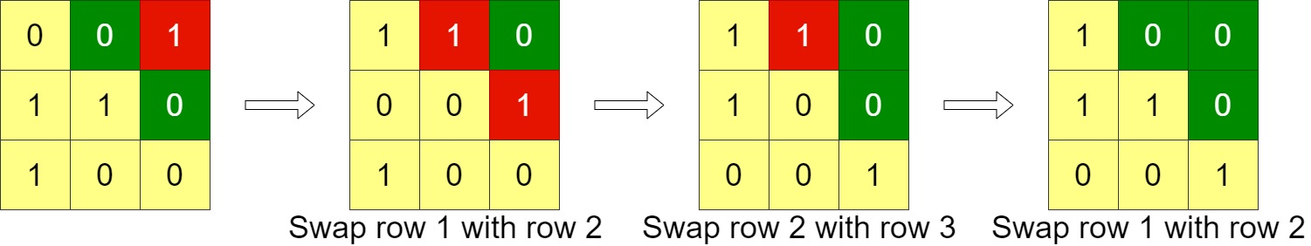

**Input:** grid = [[0,0,1],[1,1,0],[1,0,0]]

**Output:** 3

**Example 2:**

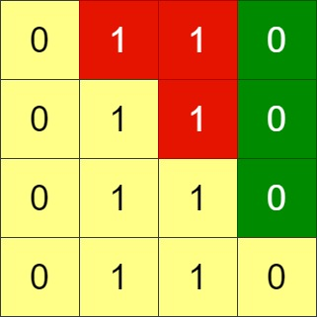

**Input:** grid = [[0,1,1,0],[0,1,1,0],[0,1,1,0],[0,1,1,0]]

**Output:** -1

**Explanation:** All rows are similar, swaps have no effect on the grid.

**Example 3:**

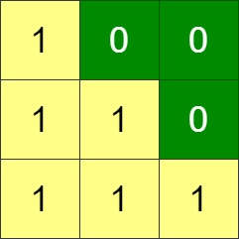

**Input:** grid = [[1,0,0],[1,1,0],[1,1,1]]

**Output:** 0

**Constraints:**

* n == grid.length
* n == grid[i].length
* 1 <= n <= 200
* grid[i][j] is 0 or 1